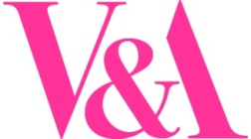

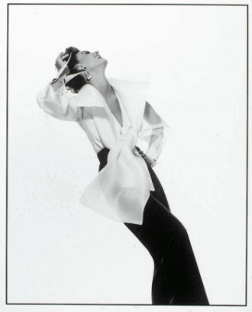
The Business History of Fashion, Italian Style
Study day for post-graduate students, researchers & final year undergraduates
Friday 7 February 2014, V&A Research Department, London
Featuring presentations from business historians, fashion historians and curators from the UK and Europe, this event provides the opportunity to meet researchers who are working to connect fashion studies, economic history, and curatorial practice. Speakers will include V&A fashion curators and other researchers who have contributed to The Glamour of Italian Fashion, 1945-2005, the V&A’s upcoming exhibition and catalogue on Italian fashion.
©GIANPAOLOBARBIERI

The event is organised by the V&A in collaboration with The Enterprise of Culture, a three-year pan-European collaborative research project investigating the international structures and connections in the fashion industry since 1945.
Programme
10.45am | Registration and tea/coffee
11.15am | The business history of the fashion industry since 1945: a new collaborative research project sponsored by HERA II  Regina Lee Blaszczyk, Chair in the History of Business and Society, School of History, University of Leeds and Project leader for The Enterprise of Culture.
11.30am | The history of Italian fashion companies  Emanuela Scarpellini, Professor of Modern History at the State University, Milan, and director of the MIC Center for Fashion Studies
12.00pm | Incorporating business history into a fashion exhibition  Sonnet Stanfill, Curator of twentieth and twenty-first century fashion at the V&A
12.30pm | Discussion
12.45pm | Lunch and a chance to see 1980s London Fashion Exhibition
2.00pm | The Italian knitwear industry  Elizabeth Currie, lecturer and researcher specializing in fashion, art and design history.
2.30pm | The Sozzani sisters and Italy's fashion industry  Oriole Cullen, Acting Senior Curator of Fashion, V&A. She specializes in twentieth and twenty first century fashion & curates the V&A’s Fashion in Motion shows.
3.00pm | The Italian textile firm Nattier  Lucia Savi, Research Assistant of the V&A’s exhibition The Glamour of Italian Fashion 1945-2014.
3.30pm | Discussion and evaluation
4.00pm | Close

The Enterprise of Culture
email: enterpriseofculture@leeds.ac.uk
website: www.enterpriseofculture.leeds.ac.uk

